5: Bank Loan Application - Zoho Creator Reports Suite

Aim:
To design and build a complete suite of Reports in Zoho Creator for the "Bank Loan Application" application, demonstrating the correct usage of all nine Report Types available in Zoho Creator.

Reports Used Overview

Report Type | Report Name
List View | Loan Application Report
Spreadsheet View | Loan_Applications_Spreadsheet
Kanban View | Loan_Status_Kanban
Calendar View | Callback_Schedule_Calendar
Map View | Applicant_Residential_Map
Timeline View | Application_Activity_Timeline
Pivot Table | LoanType_By_EmploymentType_Pivot
Chart View | LoanType_Distribution_Chart
Summary View | Loan_Wise_Summary

Detailed Report Descriptions
- Loan Application Report (List View)
  - Purpose: Default landing report for the Loan Processing Cell, displaying all loan applications in a clean, searchable tabular format.
  - Features: Includes a global search bar, sorting options, and column-level filters for applicant details, PAN numbers, email addresses, contact numbers, residential addresses, and employment types.
- Loan_Applications_Spreadsheet (Spreadsheet View)
  - Purpose: Utilized daily by loan officers to review and update application parameters quickly in a grid layout.
  - Features: Allows inline editing for specific verification and employment fields while keeping baseline applicant details read-only for data integrity.
- Loan_Status_Kanban (Kanban View)
  - Purpose: Provides a visual pipeline for tracking how loan applications progress through various review stages (e.g., Choice 1, Choice 2, Choice 3, and Deleted & Others).
  - Features: Cards can be dragged across columns to automatically update the underlying status field.
- Callback_Schedule_Calendar (Calendar View)
  - Purpose: Used by loan officers and customer support to monitor and manage scheduled client callbacks, follow-ups, and interview dates.
  - Features: Monthly, weekly, and daily grid views allowing quick identification of scheduled appointments.
- Applicant_Residential_Map (Map View)
  - Purpose: Deployed by the regional lending team to visualize the geographical distribution of applicants across regions like Chennai and surrounding areas.
  - Features: Geocode-enabled pin placement to identify high-density application zones and plan local financial outreach.

- Application_Activity_Timeline (Timeline View)
  - Purpose: Enables management to track application inflow velocity and user activities across specific hours and days of the week.
  - Features: Chronological breakdown highlighting peak periods of application submissions.
- LoanType_By_EmploymentType_Pivot (Pivot Table)
  - Purpose: Summarizes relationships between applicant birth years, names, and aggregate metrics to analyze demographic distributions.
  - Features: Provides matrix totals and grand counts for comparative internal review.
- LoanType_Distribution_Chart (Chart View)
  - Purpose: Visually compares loan distributions and demographic categories across applicants using interactive graphical nodes and filters.
  - Features: Dynamic sorting and multi-legend filters for PAN numbers and applicant attributes.
- Loan_Wise_Summary (Summary View)
  - Purpose: Aggregates core loan portfolio metrics to support credit committee evaluations and limit planning.
  - Features: Displays calculated totals and category groupings for quick executive summaries.
Screecshots:
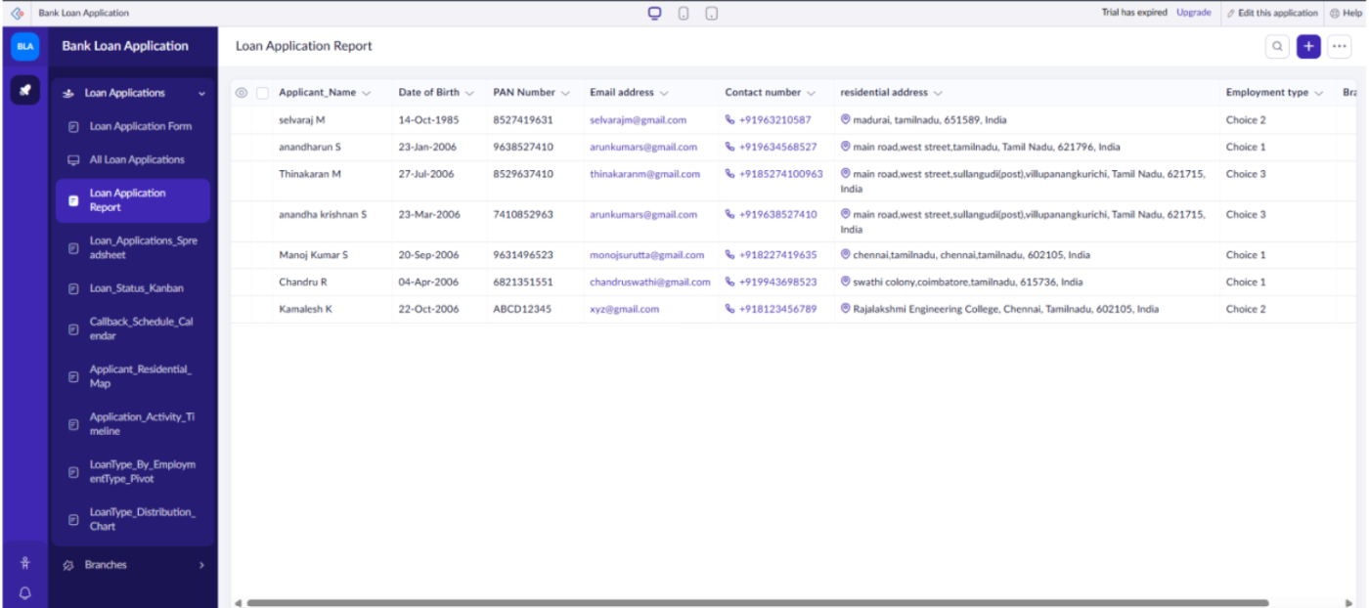

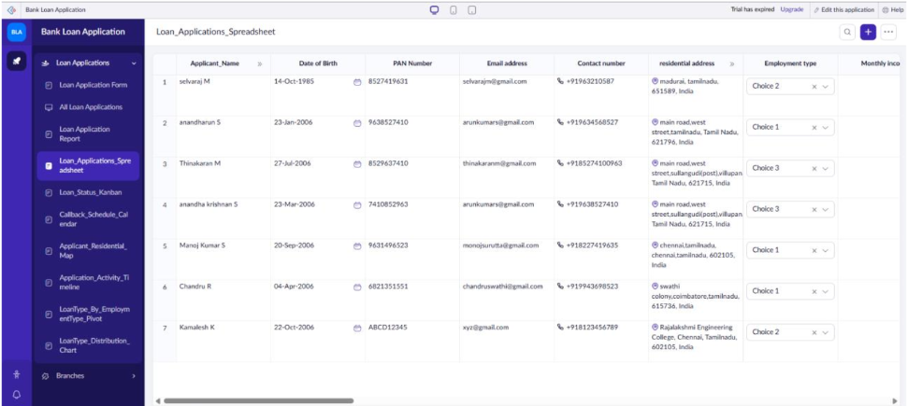
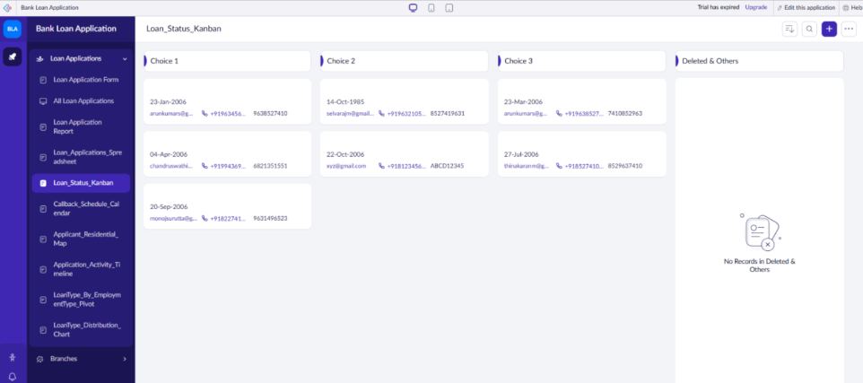

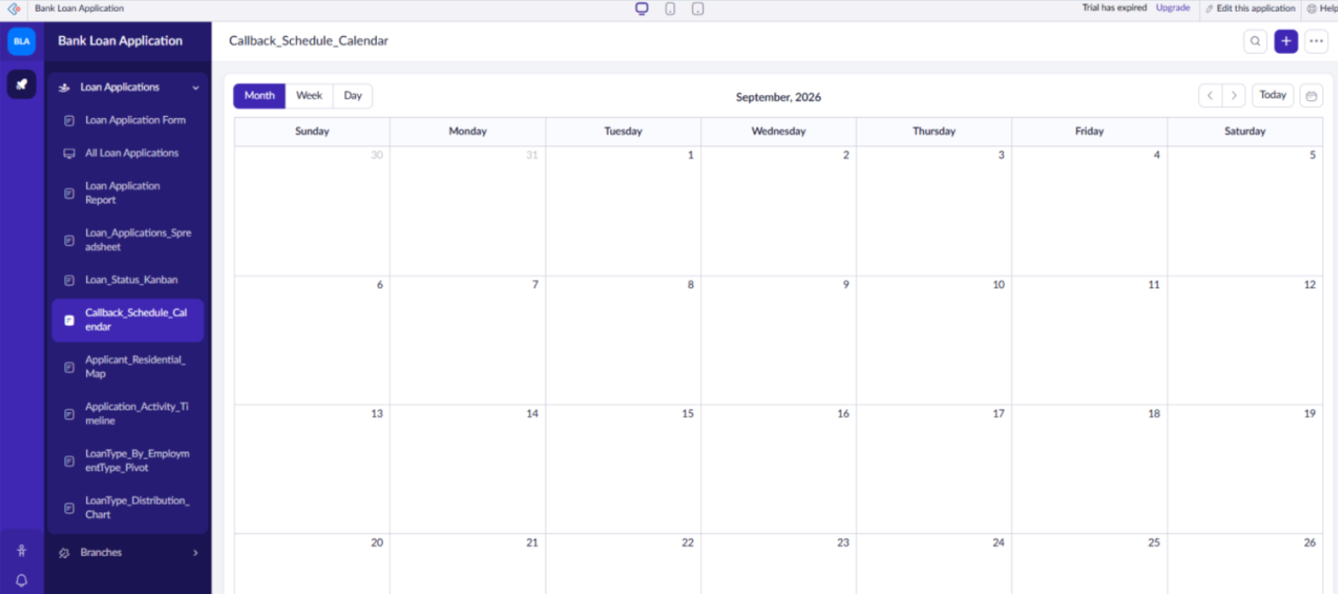
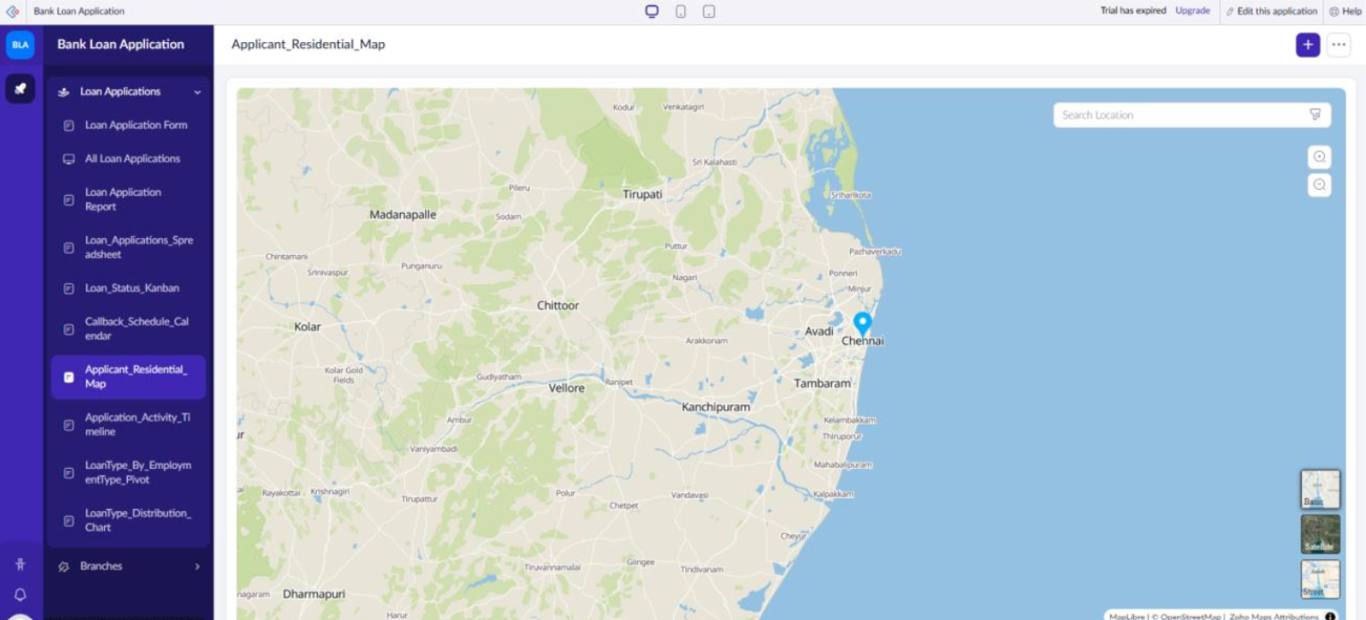

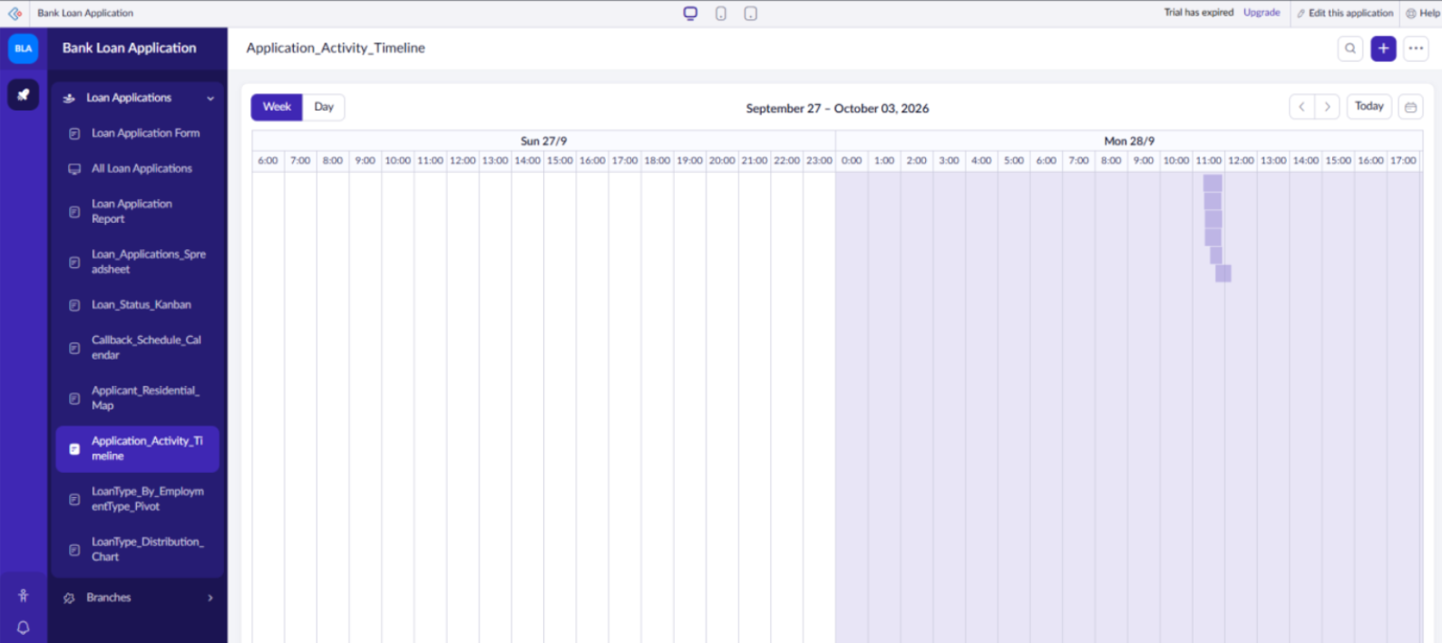
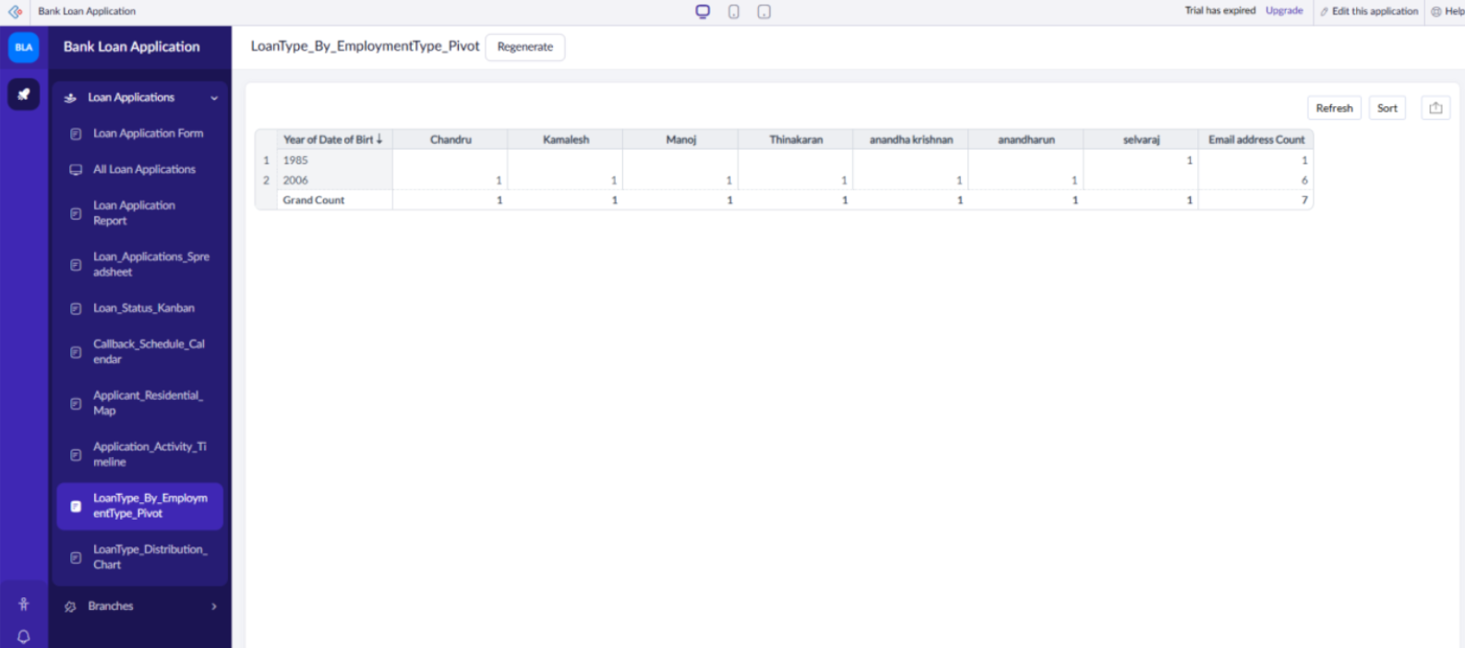

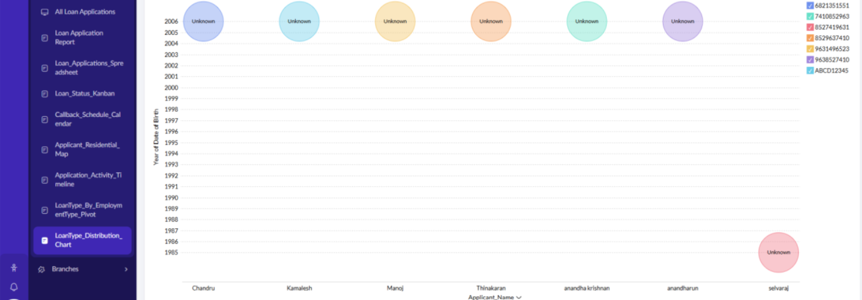

Result:
A complete suite of nine custom Zoho Creator reports for the Bank Loan Application project has been successfully configured, verified, and documented.

